M05 Chapter 9 Hands On Projects – Jadon Kosberg

- Hands-On Project 9-1
  - Packet Number 62
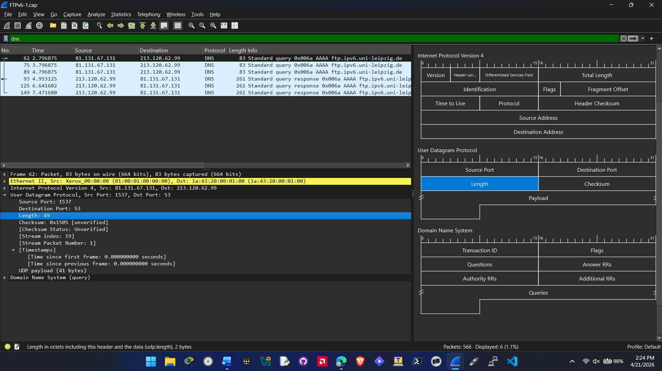
  - 8A:
Source Port number is 1537. This is a Registered Port. Which is a temporary port that is assigned by the client to receive a response from servers.
  - 8B:
Destination Port number is 53 which is the port number for DNS.
  - 8C:
UDP header length is listed at 49 bytes but that is the header and the payload the actual UDP header is 8 bytes.
  - 8D:
You can determine the upper-layer protocol by identifying the well-known port the destination port is assigned to. In this packet its port 53 which is assigned to DNS.

- Hands-On Project 9-2
  - Packet number 2
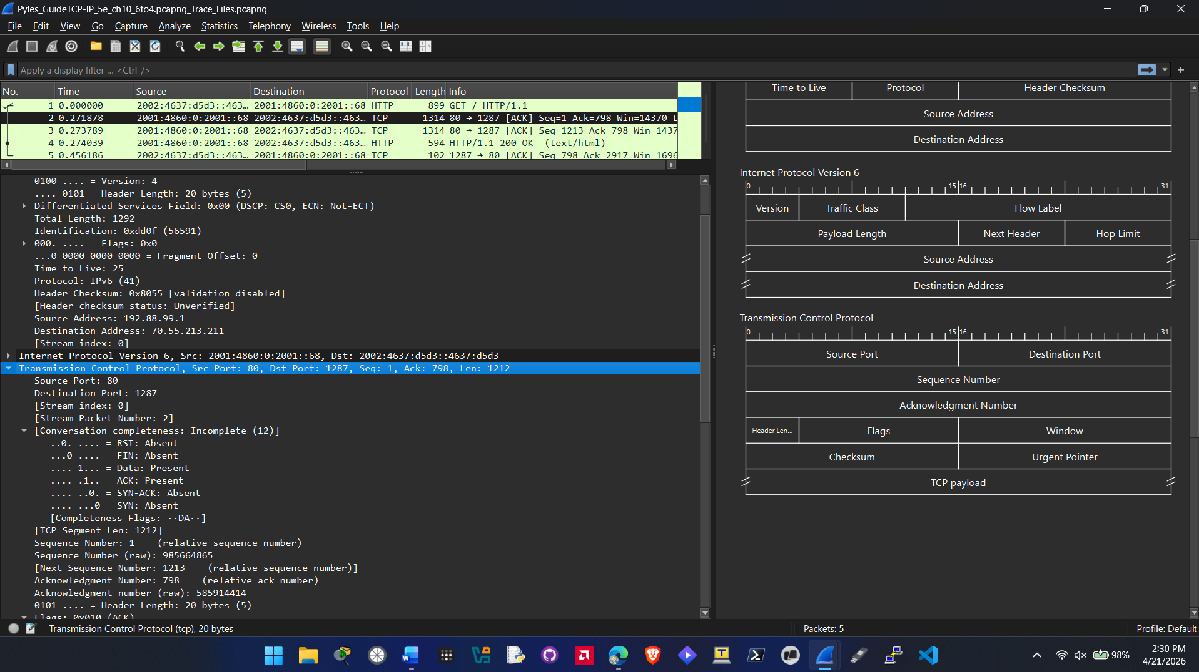
  - 6A:
Source port is 80. The protocol type using TCP for transport is HTTP since HTTP is assigned to port 80.
  - 6B:
Destination port is 1287. This indicates that it is a dynamic or private port assigned by the clients OS.
  - 6C:
The acknowledgment number for this packet is 798. It means that it has received every byte up to 797 and is not now expecting byte 798.
  - 6D:
Header length is 20 bytes.

  - Question 8: packet number 2
No, the data within the TCP section remains exactly the same. The reason is because TCP operates at a different layer of the OSI model. TCP operates at layer 4 the transport layer. While IPv4 and IPv6 operates at layer 3 the network layer. In this specific packet with encapsulation whether you are putting the TCP segment into IPv4 or IPv6 the TCP header and payload does not change.

- Hands-On Project 9-3
  - Packet Number 8, 9, 10
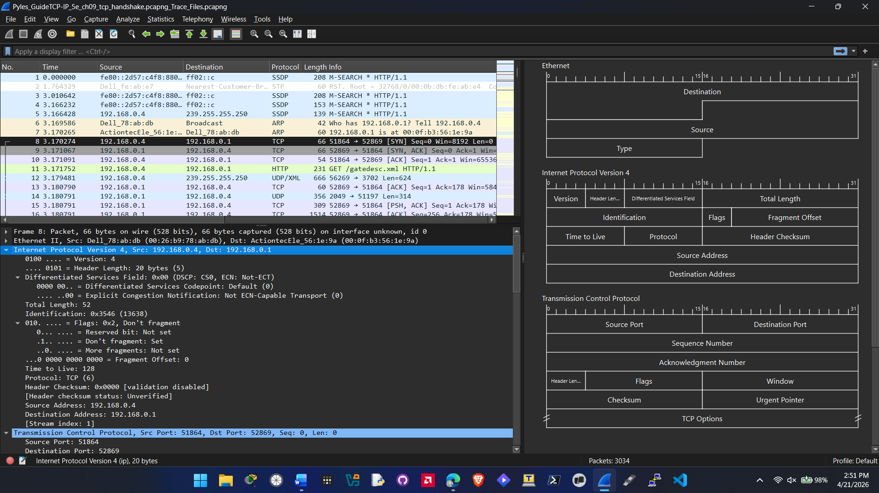
  - 4A:
The Protocol field in the IPv4 section indicates the protocol used in this packet it is TCP (6)
  - 4B:
The source port is 51864 which is an ephemeral port or a dynamic port it is assigned by the OS of the client for communication.

  - 4C:
The length of the TCP header is 32 bytes.
  - 4D:
The relative sequence number used by the source is 0.
  - 4E:
The windows size for this packet is 8192.
  - 5A:
Relative ACK number used by sender of packet 9 is 1.
  - 5B:
Yes both packets 8 and 9 use a maximum segment size value of 1460.
  - 6A:
Yes, Packet 10 is an ACK sent from the client back to the server indicating a complete TCP three-way handshake.
  - 6B:
TCP Header Length: 20 bytes.
  - 6C:
No options are defined in Packet 10. You also know this because the header length dropped back down to 20 bytes indicating the base with no options.
  - 6D:
The calculated window size is 65536.

